28-7-14: The first thing for the android app was to make an initial idea for the UI so I could start designing the app. I knew I needed a way to disconnect and connect. Forward, backward, left and right. And a way to display error messages and instructions. So I sketched the following design, the buttons will be solid although that is not illustrated here, and they will be circles with a breef description in as shown. I have yet to deside on a background, It will lightly be block coulor but that I can deside at a later date. I will need to make all of this art.

Mock up (also in assets under early idea android UI):  
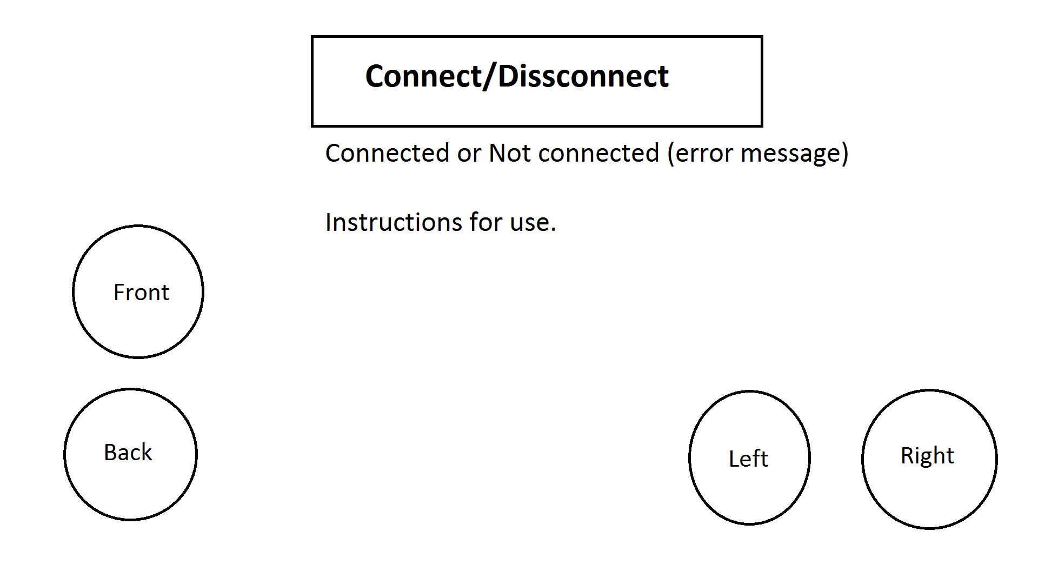

For this task I desided to use linear layouts rather than relative because that way it is morelightly to look the same on all devices and means that everything will always be in line. So I desided to use a vertical layout and have everything on its own line exept the left and right buttons where I would use a horizontal layout in side the vertical one so that they could both be on the same line. And to have those in between the front and back buttons so that there is a gap between them. For the connect button, error message and instructions I used the android:layout_gravity=”center_horizontal” so they would be centre and in the attributes for the horizontal layout I used android:gravity="right". All the buttons are forum widget buttons and all the text are text views. I have also used a small button with the attribute android:visibility="invisible" so that there is a gap.

This is the preview given by the android ADT, all the buttons will be replaced by pictures.:

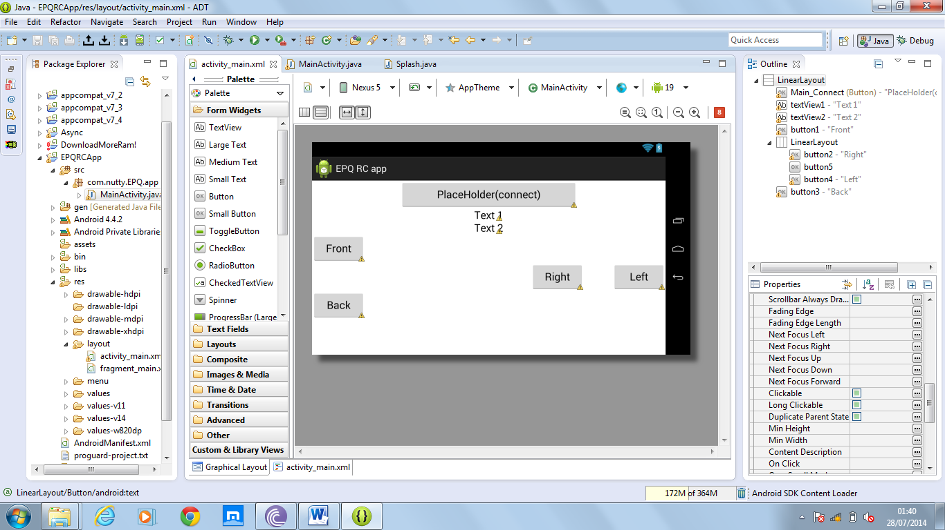

29-4-14: I have realised that I will need somewhere for the user to type the IP of the car. So I have decided to use XML preferences as this means that the IP and other data that I may need later will be permanently stored. The advantage to using this over storing it in a file on the users SD card is that it means they can’t accidently delete it and it reduces clutter on their SD card. I first tried to do this following tutorials online specifically this one <https://www.youtube.com/watch?v=zJ9qzvOOjAM>, however the method used in this (addPreferencesFromResource()) can no longer be used in that manner as of API level 11. Instead I need to use PreferenceManager.getDefaultSharedPreferences(this); to view them in java, preference fragment activity and a new activity containing “getFragmentManager().beginTransaction().replace(android.R.id.content, new PrefsFragment()).commit();” to view and edit them. I will add a ink to this activity in the top left next to the connect button.

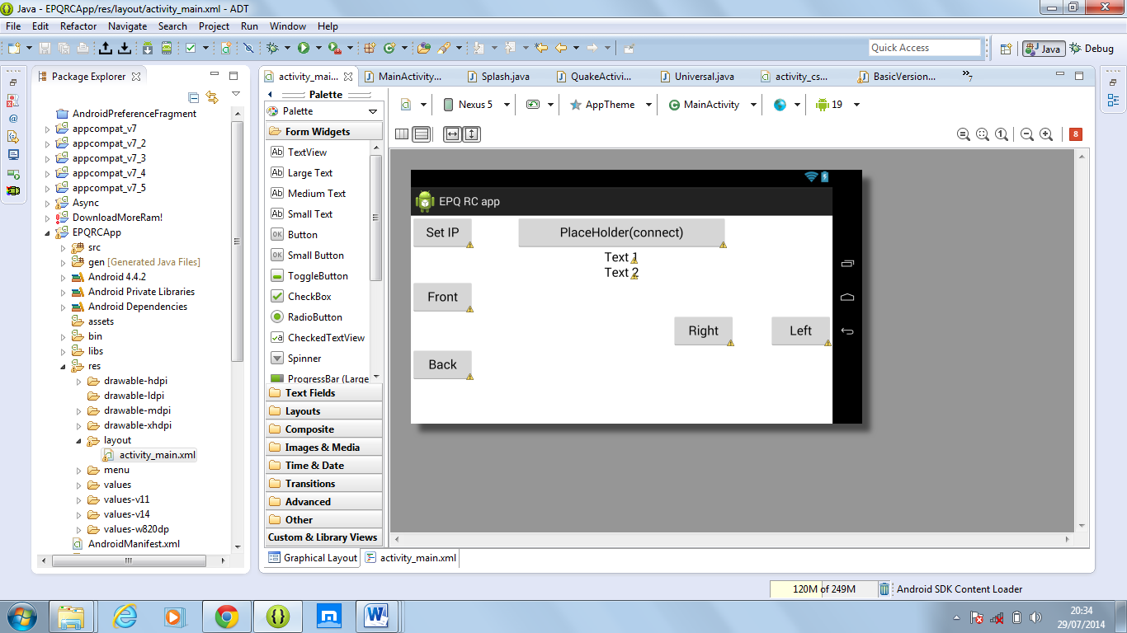

To achieve this look I had to use a relative layout. Because in a linear layout to have the connect button centred I had to use android: gravity=”centre” in the xml for the linear layout(horizontal so both buttons could be on one line) but this means that both buttons aligh with the centre so no buttons could be pushed to the far left with one centred. So I use a relative layout. On the connecting button I used the attributes: android:layout_alignParentTop="true" and android:layout_centerHorizontal="true" so it would be central. And for the set IP button I used: android:layout_alignParentLeft="true" and android:layout_alignParentTop="true" so that it would be in the top left corner.

I have also realised that I will need to lock the orientation to landscape, and hide the navigation and status bars so I can use the whole screen. But I need to research how to do this.

[about locking landscape mode and hiding bars.]